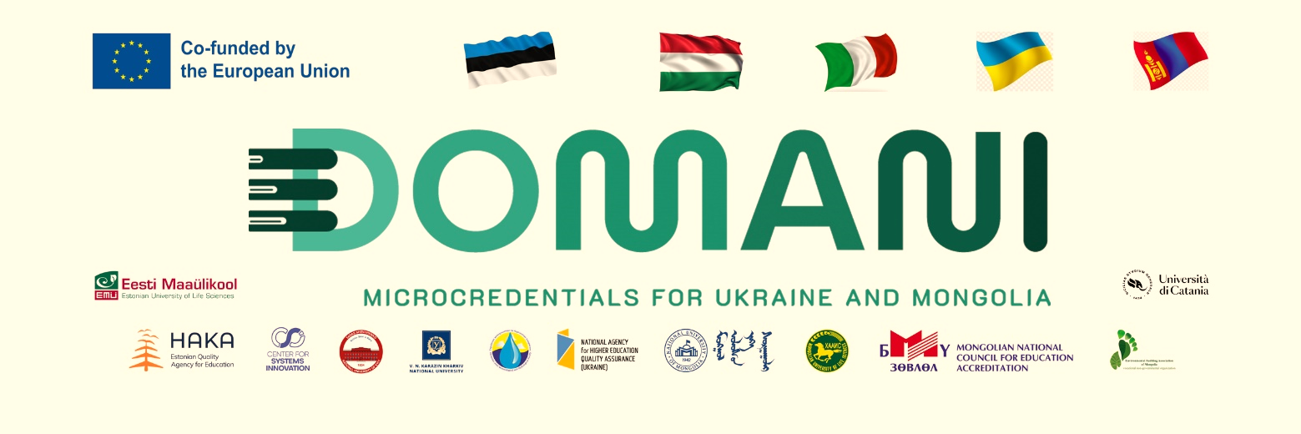
JOINT EFFORT AND VISION OF THE STRATEGIC PLAN OF NUM
AND THE “DOMANI” PROJECT

Goal 2.3 of the Strategic plan for the National University of Mongolia for the period 2025-2030 states that “Develop and implement institutional regulation on non-degree learning”, and this goal was achieved in November 2025. The working group on the development of micro-credentials regulations was established in March 2025 by the Rector's Order. The activities of the Working group were supported by the project “Developing Micro-Credentials Ecosystems in Ukraine and Mongolia for Competitive and Resilient Green Economies – DOMANI”, funded by the European Union's ERASMUS+ CBHE program.
The working group studied the short-term training regulations previously implemented by the National University of Mongolia, as well as international legal documents and recommendations related to lifelong learning, non-degree courses, and microcredit training issued by the European Union, the Organization for Economic Cooperation and Development (OECD), and the United Nations Educational, Scientific, and Cultural Organization (UNESCO). In addition, 3 international training-meetings and 2 national discussions were organized with the participation of stakeholders to enhance the knowledge and skills of employees at management and operational level in the field of microcredit training.
Thus, the institutional regulation on micro-credentials of the National University of Mongolia was approved and implemented on November 28, 2025. This regulation was developed with the concept of micro-credentials based on international experience, rather than the traditional concept of non-degree education. In the future, the National University of Mongolia intends to develop microcredit as the second main educational activity, through which it intends to increase educational income. This is in line with the provision 2.2.4.3 of the Action Program of the Government of Mongolia for 2024-2028.
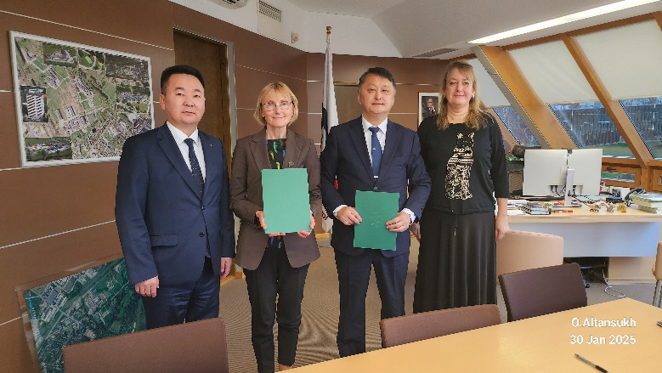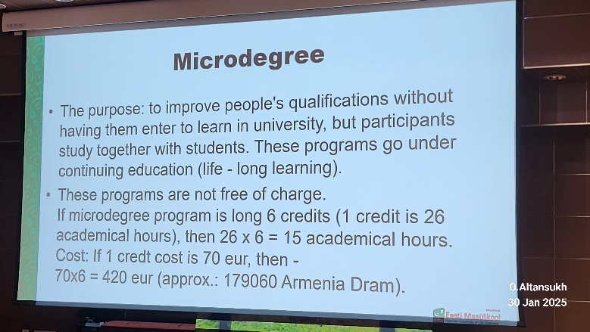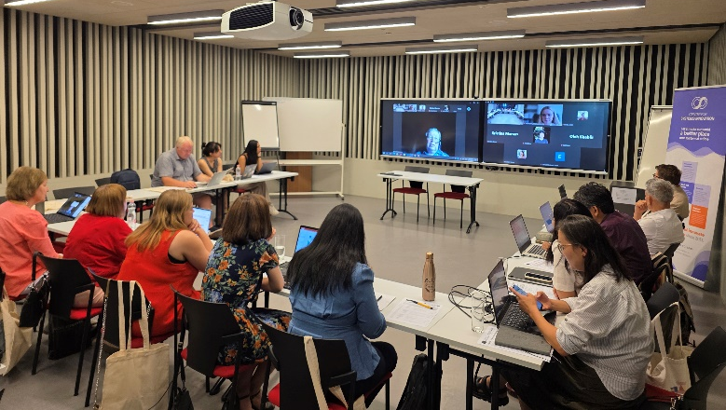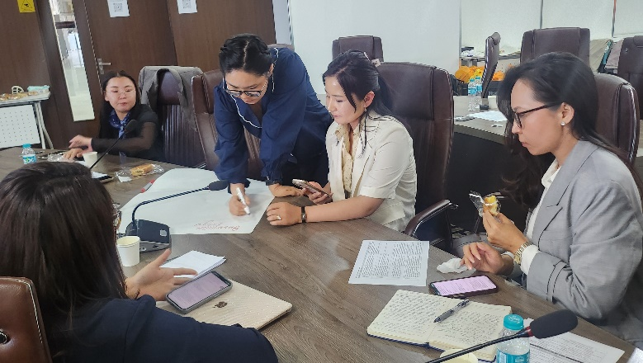
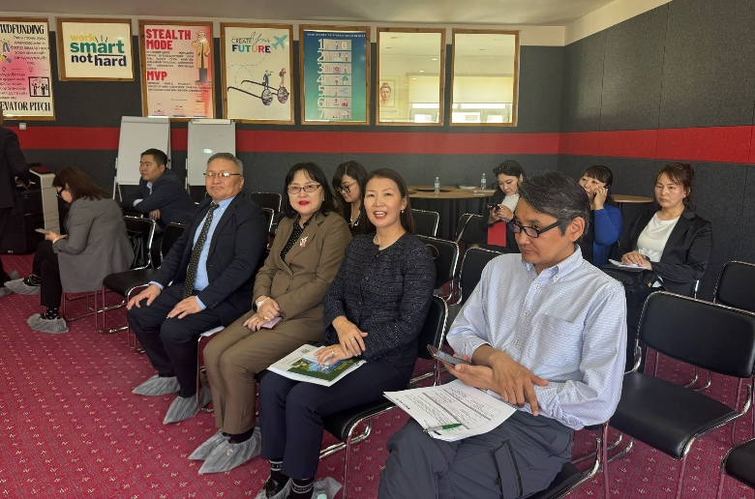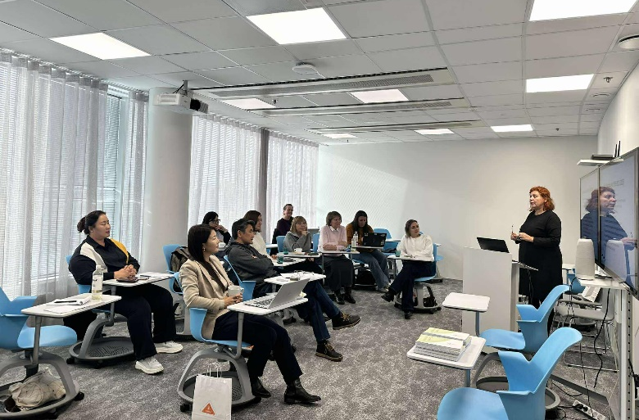
More information:
The project website: https://domaniproject.eu/
The Facebook group: https://www.facebook.com/groups/domani
Төслийн YouTube суваг: https://www.youtube.com/@DomaniProject

Reported by:
Altansukh Ochir, National University of Mongolia

Disclaimer
Co-funded by the European Union. Views and opinions expressed are however those of the author(s) only and do not necessarily reflect those of the European Union or the European Education and Culture Executive Agency (EACEA). Neither the European Union nor EACEA can be held responsible for them.
DOMANI project has been co-funded by Erasmus+ CBHE program of the European Union.

