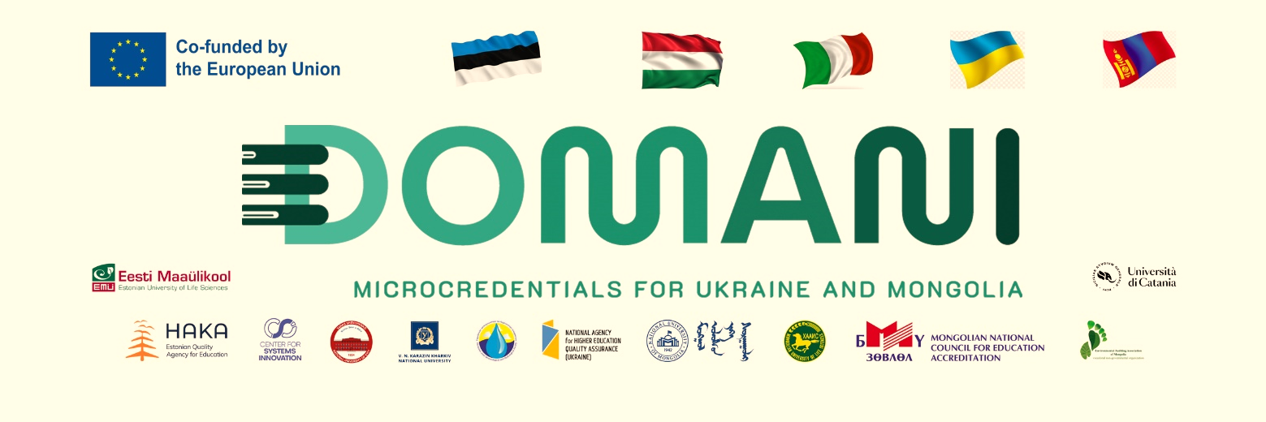
MENTORSHIP PROGRAM DEVELOPMENT AND ITS LAUNCH UNDER THE PROJECT “DOMANI”, FUNDED BY ERASMUS+ CBHE PROGRAM

The institutional regulation on micro-credentials of the National University of Mongolia was approved and started to implement on November 28, 2025. The project “Developing Micro-Credentials Ecosystems in Ukraine and Mongolia for Competitive and Resilient Green Economies – DOMANI”, funded by the European Union's ERASMUS+ CBHE program was supported to develop the regulation.
As part of the project, the mentorship program was developed in January 2026 and was presented to microcredit training instructors, undergraduate and graduate students at the beginning of the second semester of the 2025-2026 academic year, on 10 February. In total, 12 instructors and 15 students participated in the event.

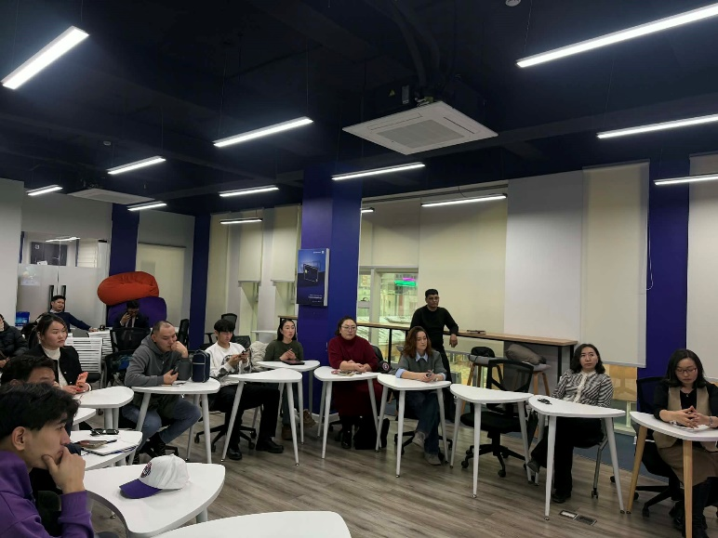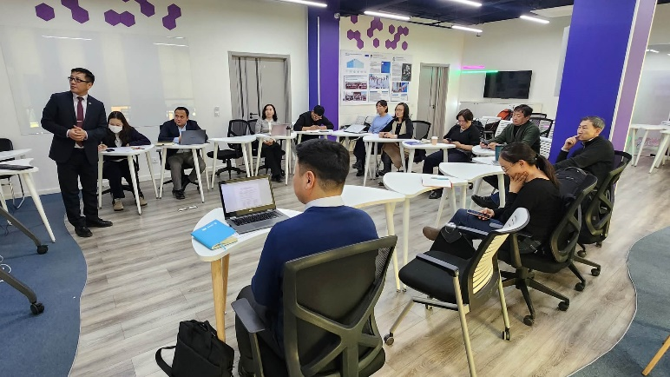

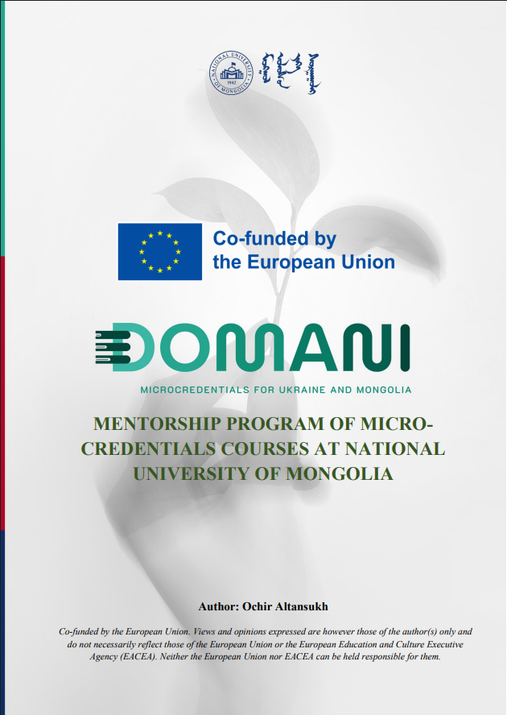
More information:
The project website: https://domaniproject.eu/
The Facebook group: https://www.facebook.com/groups/domani
Төслийн YouTube суваг: https://www.youtube.com/@DomaniProject

Reported by:
Altansukh Ochir, National University of Mongolia

Disclaimer
Co-funded by the European Union. Views and opinions expressed are however those of the author(s) only and do not necessarily reflect those of the European Union or the European Education and Culture Executive Agency (EACEA). Neither the European Union nor EACEA can be held responsible for them.
DOMANI project has been co-funded by Erasmus+ CBHE program of the European Union.

