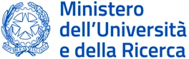

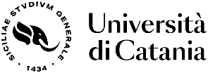

“Italy-East Asia Cooperation: from Local Expertise to a Global Outlook”
international project

A VISITING PROFESSOR AT THE UNIVERSITY OF CATANIA

Professor Altansukh Ochir, the National University of Mongolia, was invited to work as a short-term visiting professor at the University of Catania, Italy, from January 15 to 25, 2026 under the project “Italy-East Asia Cooperation: from Local Expertise to a Global Outlook” which is funded by the Next Generation program of the European Union, the Ministry of University and Research, Italy and the Domani program of the Italian Government.
The LEGO project aims to strengthen cooperation in the field of international mobility between Italian universities and those in East Asia, enhancing the educational and scientific excellence of each partner and synergising these strengths to increase their impact both internationally and on local communities and territories. The project involves 12 universities in Italy and 131 universities in East Asia and is implementing over a period of 3 years, from 2023 to 2026.
During his time as a visiting professor, he was developed a joint research proposal with the University of Catania, Italy, to focus on the social impact of the higher education institutes.
Professor Daniele La Rosa of the University of Catania will visit Mongolia in May of this year to meet and observe the actual situation of the project proposal being developed jointly.
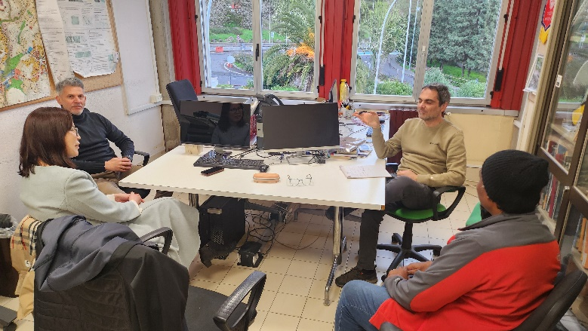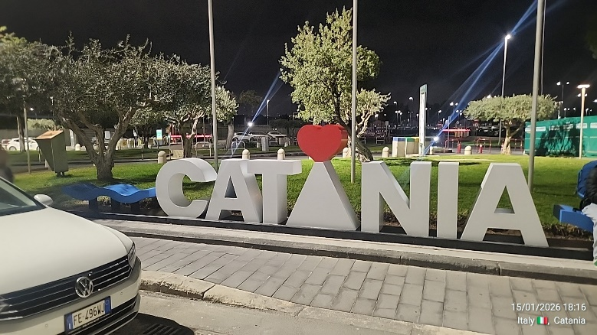

More information:
The project website: https://pric.unive.it/projects/lego/home

Reported by:
Altansukh Ochir, National University of Mongolia

Disclaimer
Funded by the European Union. Views and opinions expressed are however those of the author(s) only and do not necessarily reflect those of the European Union. The European Union can’t be held responsible for them.

