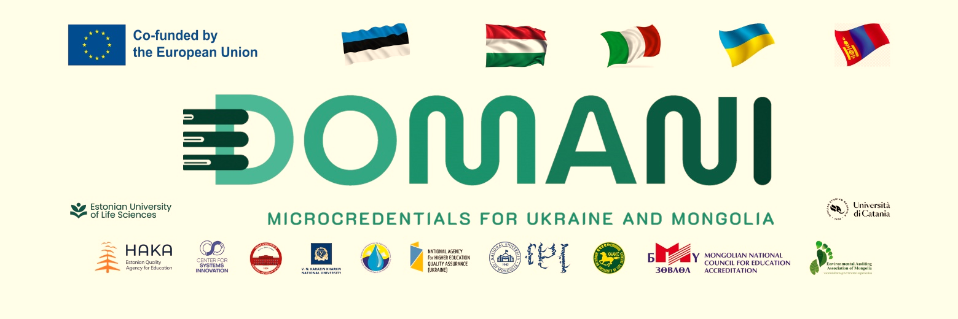
“PUBLIC SCIENCE” PODCAST EQUIPMENT

In order to disseminate scientific knowledge that accumulated at the National University of Mongoli to the public and increase social impact of the university, the National University of Mongolia is making the podcast “Public Science”. The initiative is supported by the project “Developing Micro-Credentials Ecosystems in Ukraine and Mongolia for Competitive and Resilient Green Economies – DOMANI” funded by the European Union’s ERASMUS+ CBHE program, and the following equipment for podcast has been provided to the Digital Professor Studio of the Center for Faculty Development and Learning Support, the National University of Mongolia. These include:
- Rode brand podcast microphone and mount, 3 pcs
- Rode brand professional sound mixer, 1 pc
- Sony brand podcast headphones, 3 pcs
- Rode brand wireless microphone, 3 pcs
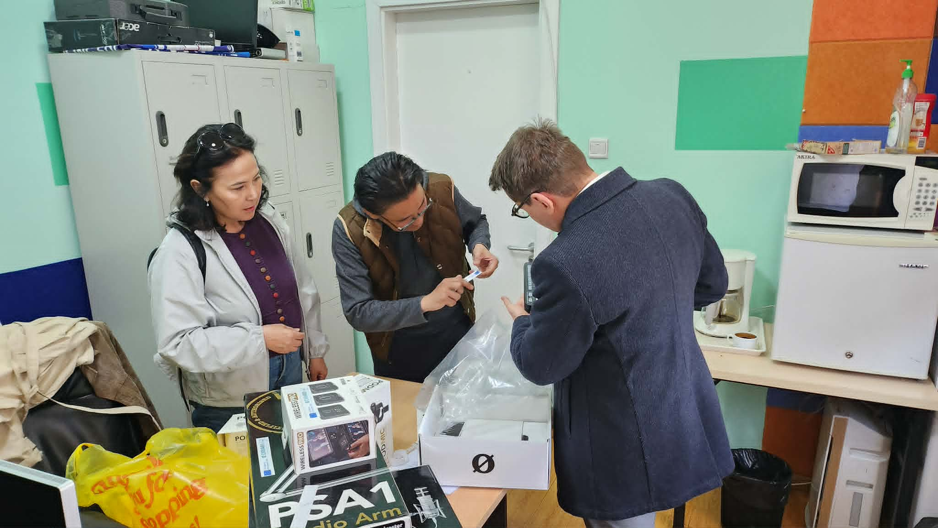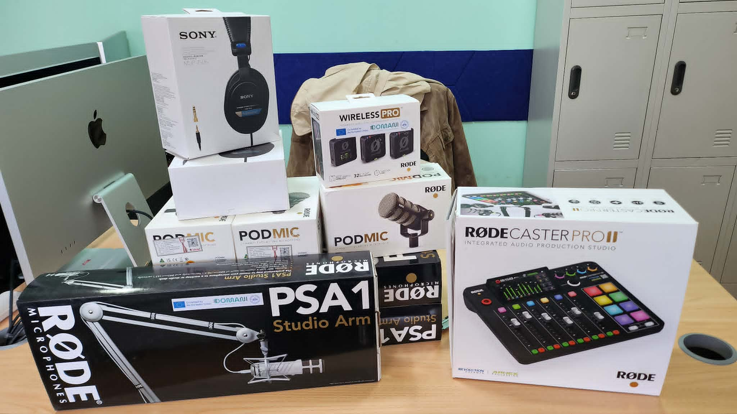
The Digital Professor Studio
The Center for Faculty Development and Learning Support
DOMANI-NUM teams

More information:
The project website: https://domaniproject.eu/
The Facebook group: https://www.facebook.com/groups/domani
The YouTube channel: https://www.youtube.com/@DomaniProject

Reported by:
Altansukh Ochir, National University of Mongolia

Disclaimer
Co-funded by the European Union. Views and opinions expressed are however those of the author(s) only and do not necessarily reflect those of the European Union or the European Education and Culture Executive Agency (EACEA). Neither the European Union nor EACEA can be held responsible for them.
DOMANI project has been co-funded by Erasmus+ CBHE program of the European Union.

