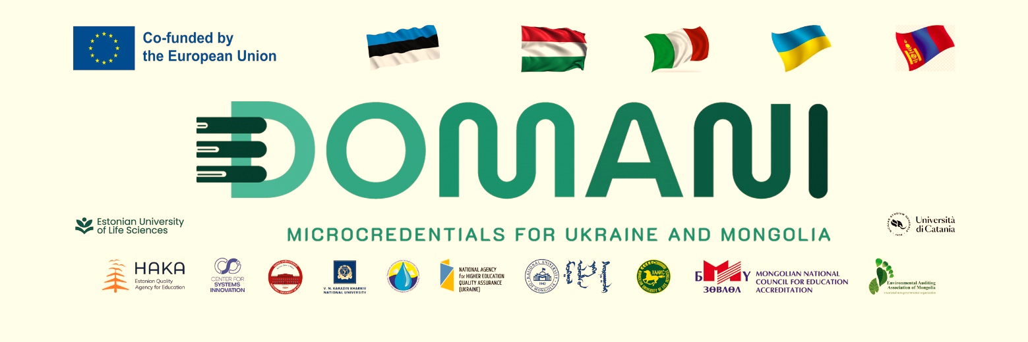
A MEETING TO INTRODUCE, DISSEMINATE AND EXCHANGE INFORMATION ON AN INTERNAL REGULATION OF MICRO-CREDENTIALS OF THE NATIONAL UNIVERSITY OF MONGOLIA WAS SUCCESSFULLY ORGANIZED

Within the framework of Objective 2.3.2 of the Strategic Plan for the Development of the National University of Mongolia until 2030 and the project “Developing Micro-Credentials Ecosystems in Ukraine and Mongolia for Competitive and Resilient Green Economies – DOMANI” funded by the European Union’s ERASMUS+ CBHE program, the National University of Mongolia is adopting and implementing the “Internal regulation on micro-credentials” in November 2025. A meeting with the aim of introducing the regulations, and the implementation process to the public and exchanging opinions was organized on April 30, 2026 by the Office for Academic Affairs, Curriculum and Program Quality Assurance, NUM in collaboration with the DOMANI project team in room 506 of the Faculty and Student Development Center. The meeting was attended by 25 people from 14 internal and external organizations of the National University of Mongolia, was presented 4 topics, questions and answers, and held discussions. The presentations were:
- Introduction to the institutional regulation on MC – Prof. Bulgantamir
- European experience on MC – Prof. Altansukh
- MC experience and development of Estonia – Prof. Anton Shkaruba
- MC experience of NUM – Assoc Prof. Delgerjargal
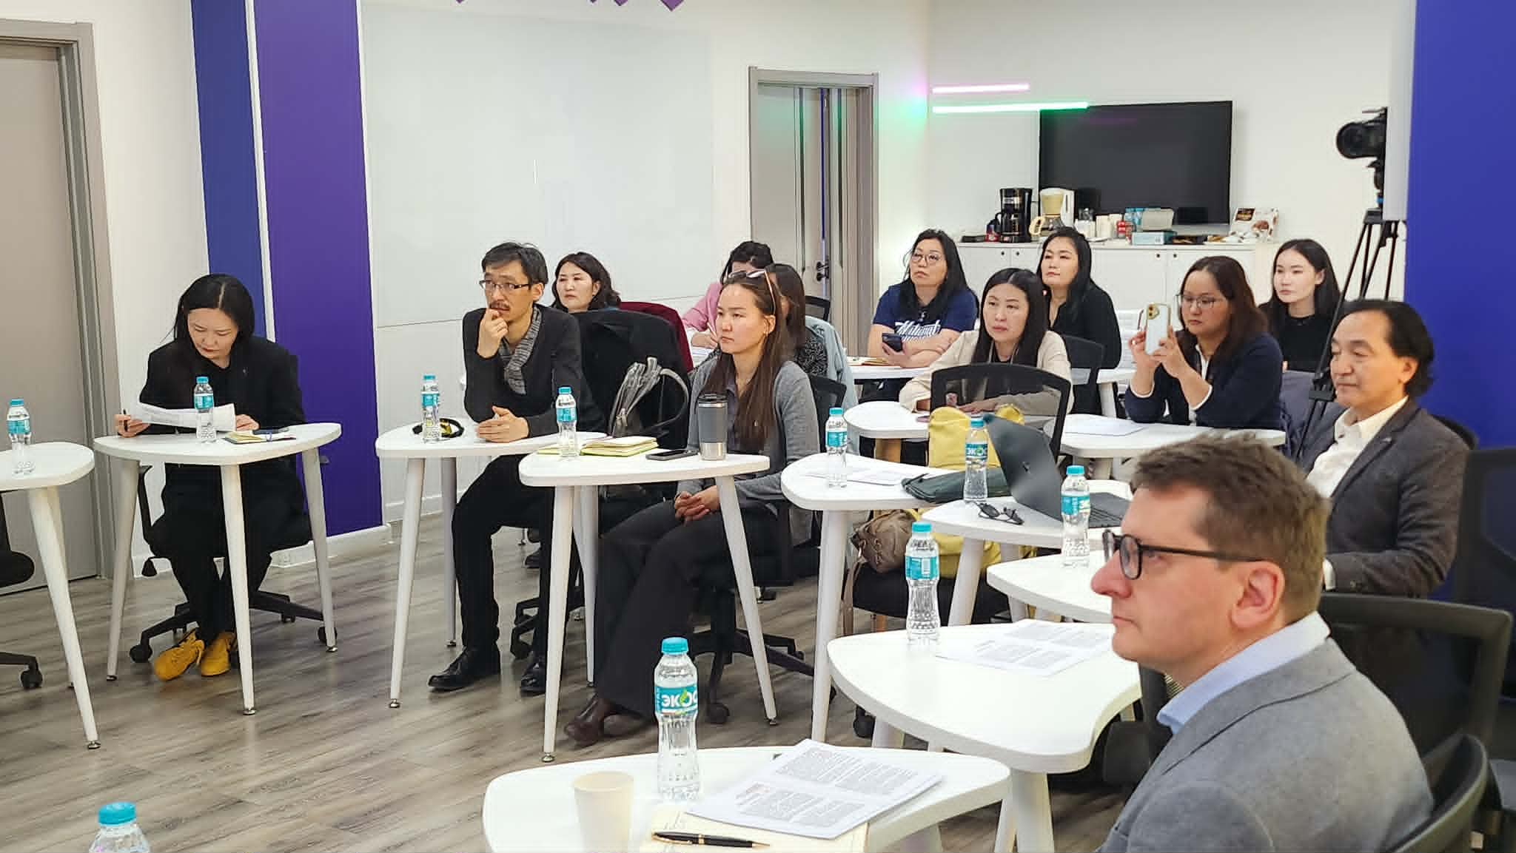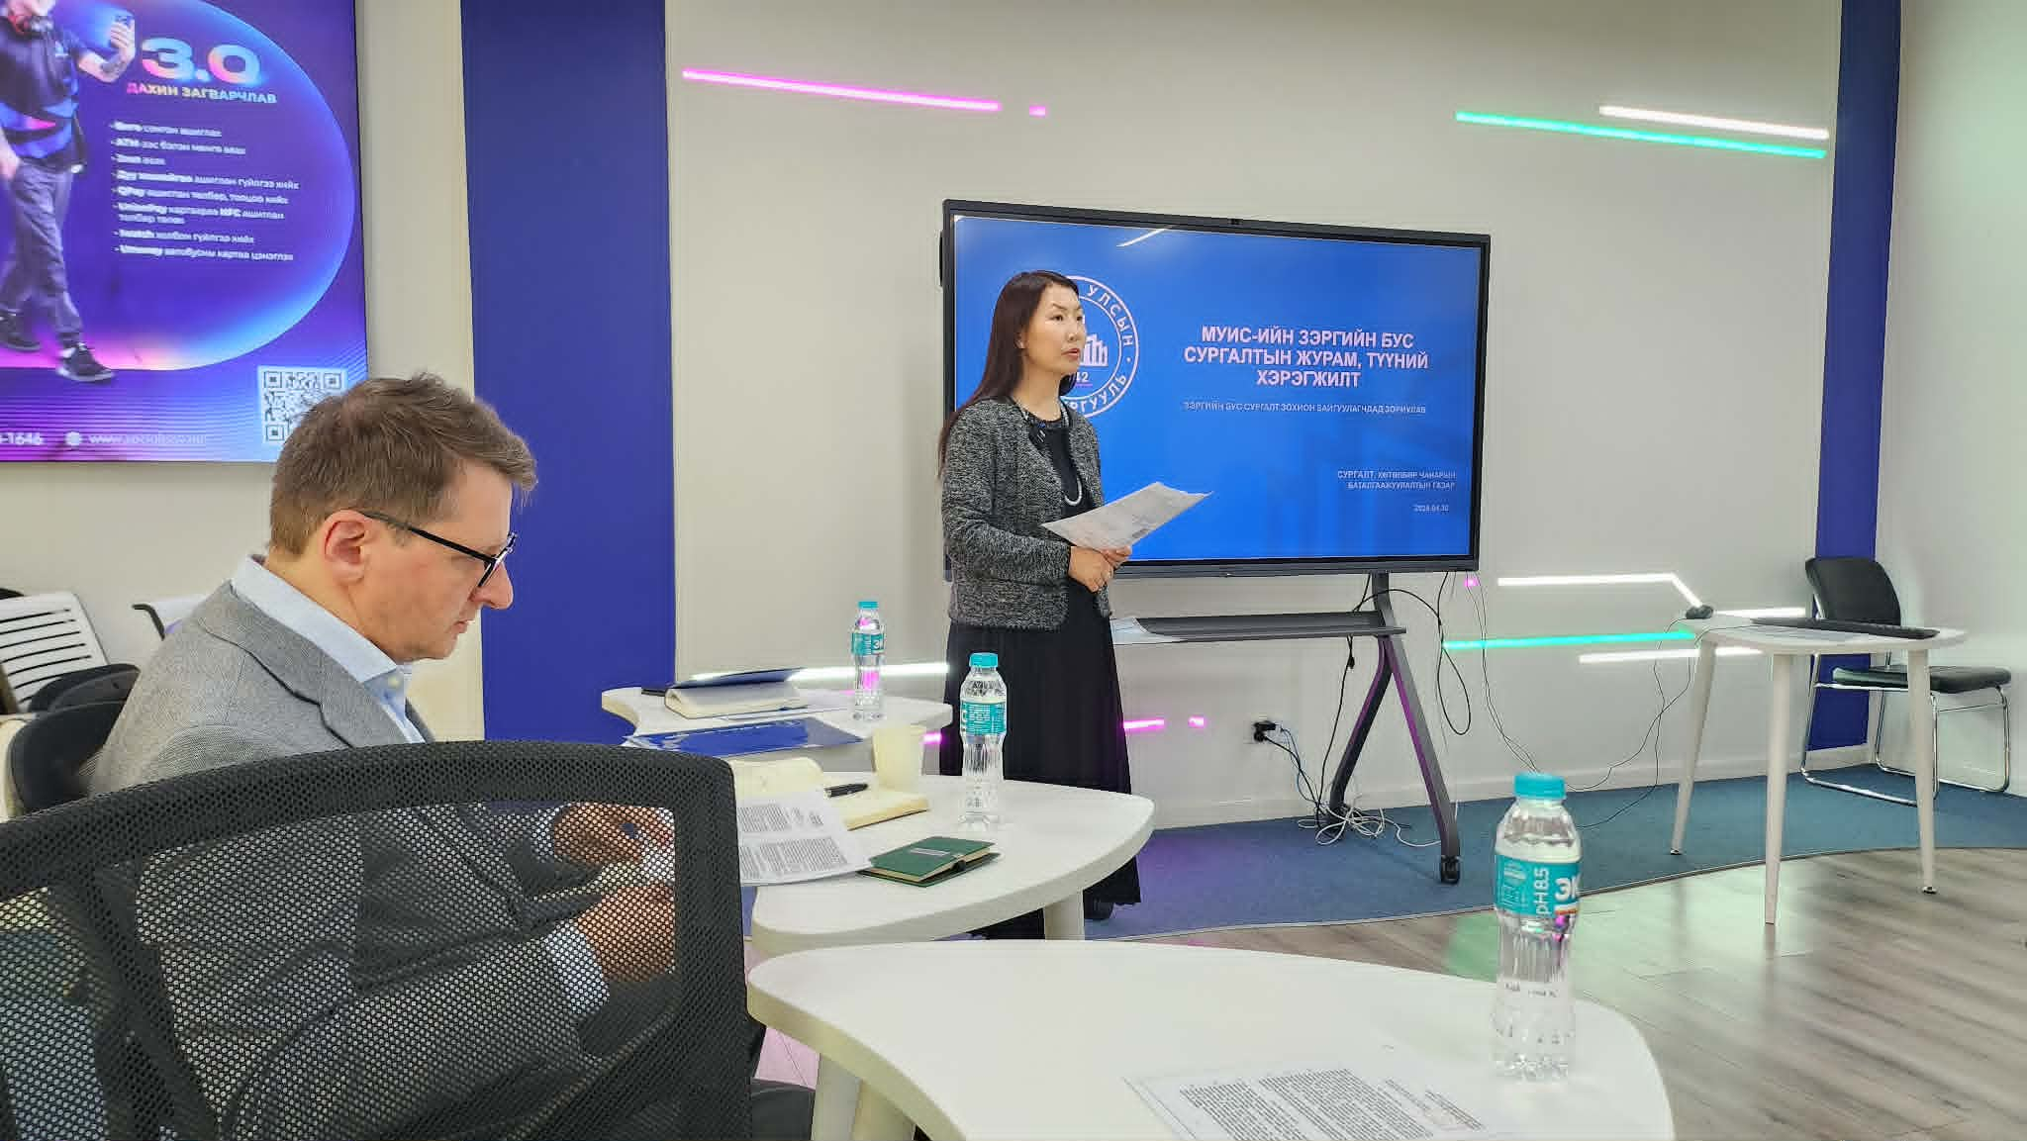
More information:
The project website: https://domaniproject.eu/
The Facebook group: https://www.facebook.com/groups/domani
The YouTube channel: https://www.youtube.com/@DomaniProject

Reported by:
Altansukh Ochir, National University of Mongolia
Disclaimer
Co-funded by the European Union. Views and opinions expressed are however those of the author(s) only and do not necessarily reflect those of the European Union or the European Education and Culture Executive Agency (EACEA). Neither the European Union nor EACEA can be held responsible for them.
DOMANI project has been co-funded by Erasmus+ CBHE program of the European Union.

