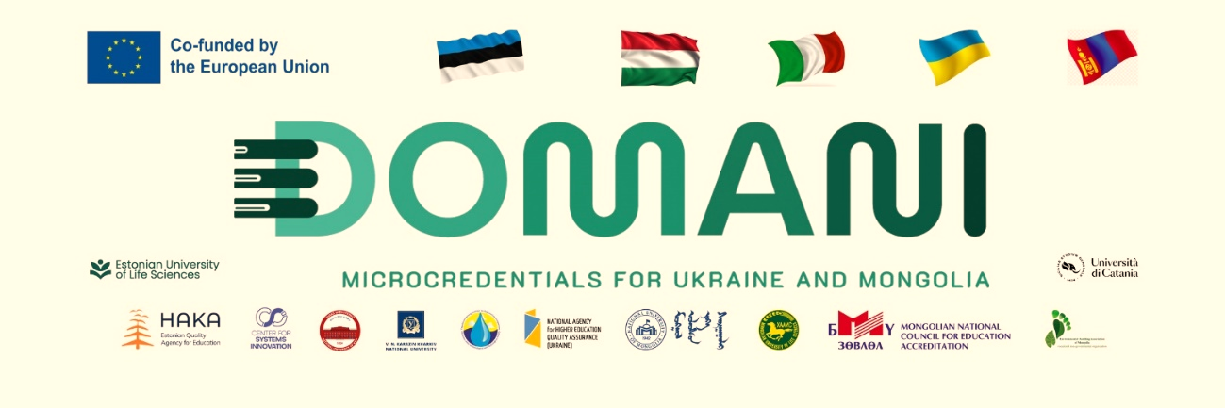
NUM FACULTY AND STUDENTS PARTICIPATED IN THE INTERNATIONAL SUMMER SCHOOL OF THE “DOMANI” PROJECT, FUNDED BY THE ERASMUS+ CBHE PROGRAM.

Faculty members, researchers, and students from the Institute for Sustainable Development and the Department of Environment and Forest Engineering, School of Engineering and Technology of the National University of Mongolia, participated in the "NATURATION – Nature-based urban regeneration" international summer school, which was held in Catania, Italy, from September 15 to 29, 2026, under the project “Developing Micro-Credentials Ecosystems in Ukraine and Mongolia for Competitive and Resilient Green Economies – DOMANI”, which is funded by the ERASMUS+ CBHE program. It was organized by project partner the University of Catania. The event brought together 25 representatives from 7 organizations across 5 countries (Italy, Estonia, Hungary, Mongolia, and Japan).
This summer school covered four core topics over a 14-day period, with the first seven days held in person and the final seven days conducted online.
- NbS envisioning: Planning and designing resilient green infrastructures.
- Ecosystem assessment: Quantifying the benefits of urban nature (cooling, water, air).
- Space regeneration: Transforming built-up areas into biodiverse community hubs.
- Policy & Governance: Funding and implementing real-world green transitions.
Professor O.Altansukh lectured on “Urban water management: The city blueprint approach”, while Associate Professor N.Oyunchimeg also lectured on “Nature-based solutions for sustainable urban development: Global perspectives and lessons from Ulaanbaatar”. Throughout the summer school, students worked in five teams, and at the end of the school, the NUM team was recognized as one of the top two teams during the presentation of their independent projects.
Following the summer school, a meeting of the DOMANI project's Steering Committee was held to discuss the project's results and progress until now, as well as future activities, and to deliberate on how to manage emerging international risks to the project.
It has been decided to organize the following two activities in Mongolia under the project's 2026 action plan. These are:
- International hackathon in Darkhan City in August 2026
- International conference on micro-credentials in Ulaanbaatar City in August 2026
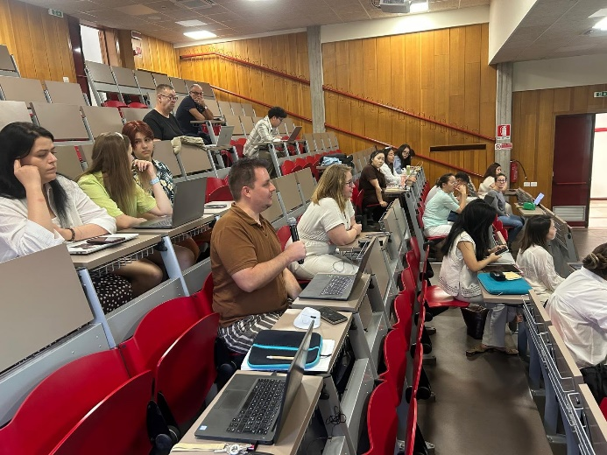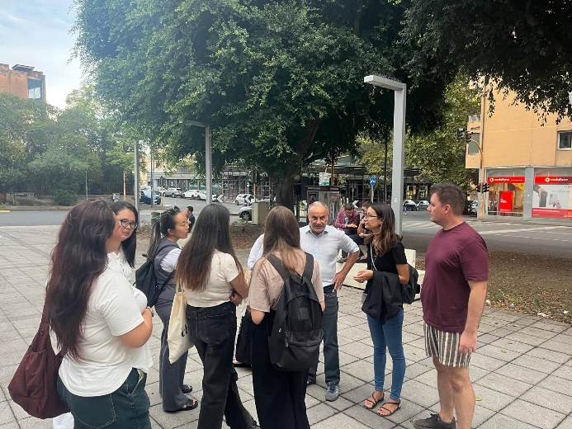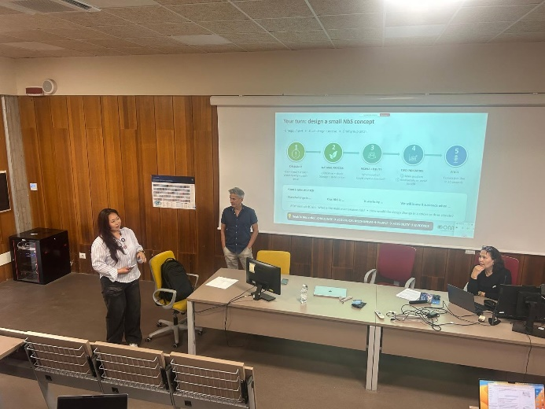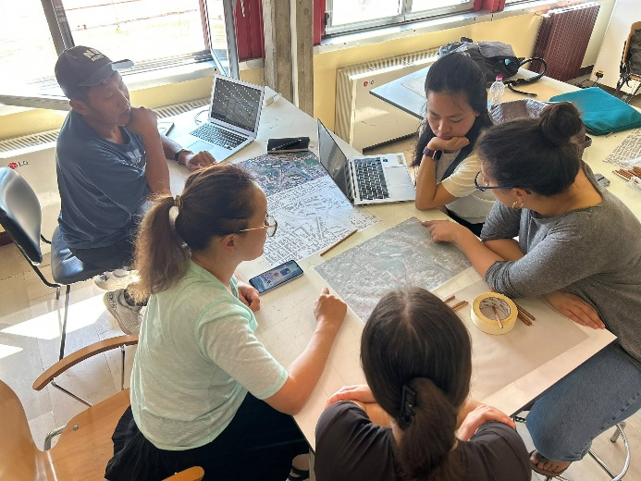

More information:
The project website: https://domaniproject.com/
The Facebook group: https://www.facebook.com/groups/domani
The YouTube channel: https://www.youtube.com/@DOMANIErasmus_plus_project

Reported by:
Altansukh Ochir, National University of Mongolia

Disclaimer
Co-funded by the European Union. Views and opinions expressed are however those of the author(s) only and do not necessarily reflect those of the European Union or the European Education and Culture Executive Agency (EACEA). Neither the European Union nor EACEA can be held responsible for them.
DOMANI project has been co-funded by Erasmus+ CBHE program of the European Union.

